How to choose colours

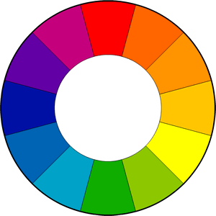

Saturation and Value

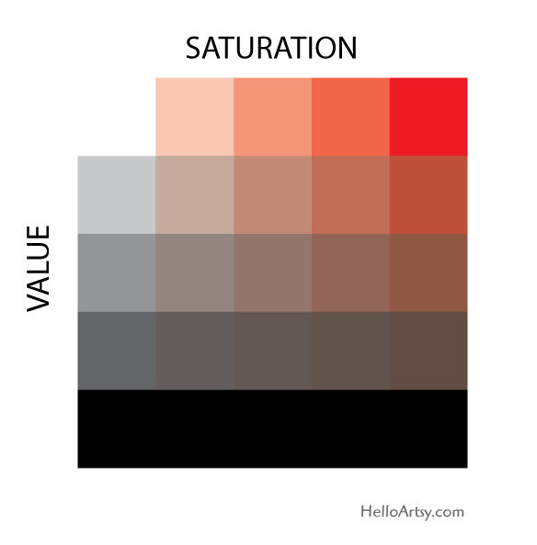

Saturation: Intensity of the colour

Value: Brightness/Darkness of the colour

In a nutshell:

-Don’t overdo it (The viewer needs to rest the eyes, best for highlighting areas of interest)

-Use values of high contrast to guide the viewer and/or draw attention (Ex: using red on a space when all the painting is guided towards the blues and greens)

-Use it to change the mood (Colours with more valour can be used to portrait sadder stories/moments)

Colour Harmonies

Monochromatic



In a nutshell:

-Uses only one colour

-Best for single subjects

-Atmospheric (Can portrait the ambient very intensively only changing the saturation and value of the colour)

Analogous

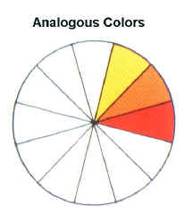

In a nutshell:

-Colours adjacent on the wheel

-Easy on the eyes

-Peaceful, comfortable mood (Because it’s generally seen on the nature)

Triadic

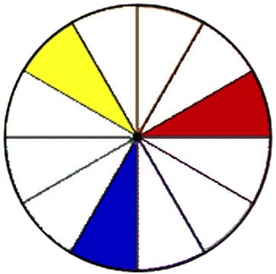

In a nutshell:

-Equally distant on the wheel

-Hard to pull off

-Best for cartoon/surreal scenes

Complementary

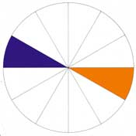

In a nutshell:

-Opposing on the wheel

-Naturally appealing to the eye

-Use one colour predominantly (Generally the weaker colour, in this case the orange(desaturated) with splashes of the stronger colour highly saturated)

Split Complementary

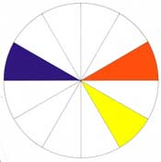

In a nutshell:

-Similar to complementary but with one end extended

-More creative freedom

-Feels lively, joyous

Tetradic (Double Split Complimentary)



In a nutshell:

-Two pairs of opposite colours

-Best used for backgrounds/foregrounds

-Never use 25% each (Use mainly the weaker colours and splashes of the stronger ones)

-Hard to pull off but pleasing results